A DREAM COME TRUE

Srila Prabhupada’s Struggle In Bombay And Finally Successful Departure For United States

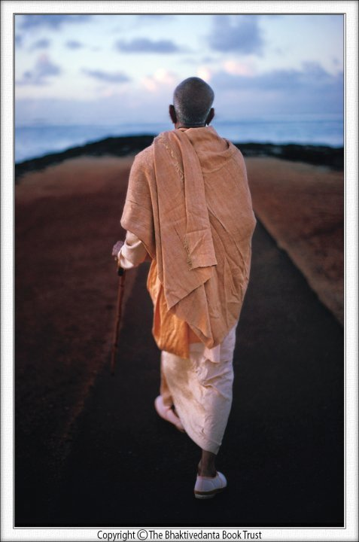

A devotee just follows Lord’s commands

Wherever whenever Lord’s will demands

Being fully surrendered to the Lord

Bhaktivedanta Swami moved forward

Swami’s mission was Krishna’s own will

Without any personal agenda to fulfill

Guru’s order boiling in heart’s core

Swami came to the Bombay’s shore

Time passed by and no bright way

Swami grew older and non-fray

Now no more selling books or printing

“Going America” was the only thinking

With ready passport and sponsorship

He visited owner of Scindia Steamship

Meeting secretary of the company owner

He submits his plea with sponsor paper

Secretary went to Sumati Morarji

With the earnest request of Swamiji

“Swami is pleading to go to America

For teaching people about Sri Krishna.”

Morarji denied the idea strongly

Swami was too old for this journey

“Where he will live? What he will eat?

Let in India his all work be complete.”

Yet Swami twice resent the secretary

But Morarji sent him back negatively

Swami requested a meeting finally

With hope to convince her personally

Swami has nothing to do with America

Neither with India, nor with Scindia

His worry was only his Guru’s order

He saw it to be ever delaying further

Carrying bold determination within

Grey haired old Swami entered in

His request cried, loud, emphatic

“Please give me one ticket!”

All these years Swami was trying

Pushing forward Guru’s each saying

This seemed to be last opportunity

Morarji then replied back to Swami

“No one to receive you, no one to see

In old-age sickness, no one to heel

What you will eat and you will drink?

Please analyze everything and think?”

“My secretaries think, please hear

Swami is really going to die there”

Sumati rejected Swami’s last request

Swami disagreed her question’s quest

Swami made a face of dismissing

These are all hurdles obstructing

His decision was fixed and clear

Preaching about Krishna everywhere

Sumati said, “You are my father

How can I lose you for-ever?

By allowing you to go alone

I can’t leave you die gruesome”

Swami heard silently all her cause

There was total silence and pause

With remaining final faith and hope

The last words then Swami spoke

“You say this all but don’t do bother

Even the smallest plea of your father

My spiritual master said me to preach

Kindly, please help me go out to teach

To fulfill my Guru’s each teaching

I will go every possible reaching”

This was Swami’s final plea

“Okay Swamiji”, said Sumati

“Battle USA” was not yet over

“P-form” was necessity another

No US Visa and other permission

Alone in Bombay, without habitation

Sumati made arrangements for Swami

He lived in Bombay in Scindia colony

With only his trunk and typewriter

Swami stayed in unfurnished shelter

For him opulence was not in matter

He was special sadhu and scholar

Some neighbors became interested

After knowing what Swami intended

Though old, he never stopped preaching

Widely spreading Chaitanya’s teaching

He would go every town, village, city

Swami became people’s new celebrity

Rice, sabji, fruits all families brought

So much so that he never even thought

He distributed whatever excess remains

Fortunate children in colony got remnants

Older residents assembling together

Visited Swami daily in order to hear

Rare teachings from the Bhagavata book

More rarer were purport that Swami took

Mr. Vasudeva, chief cashier of Scindia

Impressed with Swami Bhaktivedanta

He visited Swami to learn regularly

Also purchased all books of Swami

Writing, chanting were Swami’s only activity

Neighbor Nagarajan asked out of curiosity

“Swamiji, what are you so intensely writing?

I observed you whole day only translating”

Swami confidently gave him his two books

“Child you will know, just read these books”

Every day he went out trying, demanding

His visa and P-form were still pending

He himself pushed his books’ selling

Searched sponsors for further publishing

He looked for various pious professional

Who could make some help financial

Swami used to return in evening

After whole day’s lonely tussling

Old Bhaktivedanta unsupported

Tired deadly, morose, unattended

But his work has not yet ended

He again wakes up rejuvenated

Determined service unparalleled

His glorious writing again resumed

Each day was even more challenging

No one came forward in helping

Swami carried on his work still

Sitting in room chair or windowsill

Nagarajan asked Swami of preaching

How much was his full day collecting?

“Not much today, it is depressing”

Swami replies back complaining

“Time is currently not rightly ours

People are all arrogantly oblivious

Nobody is now fully understanding

My all these endeavors’ necessity”

After a minute Swami starts again

His tireless work will not go in vain

He becomes tired, but never defeated

Never ever any discouragement reflected

Some people would come to Swami

Hear discourses and gave some money

Since his work had endless demanding

For any help he was always appreciating

Swami had endless wisdom to teach

But he has got no support to preach

Working hard for his loving master

Swami personified selfless character

In the service of his dear Lord Hari

He can spend whole world’s money

But he walked two miles to save money

Daily Andheri station to Schindia colony

Mrs. Morarji wanted to hear Bhagavatam

She knew Swami’s unparalleled wisdom

For about two weeks Swami recited

The sublime teachings and commented

People at Scindia helped and assisted

To get Swami Visa-form fully accepted

He had help in US for sponsorship

And now backing by Scindia Steemship

On July 28th (1965), his visa came,

But P-form was another hard game

Proceedings were slow and everyday battle

It seemed to be insurmountable obstacle

No assistance, no tangible helping

The old Swami was alone struggling

Swami visited Matachori for meeting

Inquired about his P-form passing

Metachori replied him fully negating

All chances of P-form’s passing

“You are just sponsored privately

No institution called you officially”

“How would you be taken care,

If you will be forsaken there?

I have now decided to cancel it

You going there is not at all fit.”

Swami requested to meet manager

His decision of going cannot alter

Mr. Rao, manager, agreed finally

P-form, visa were now fully ready

Now the time of great fortune began

Krishna was unfolding His secret plan

Swami was now ready with everything

To finally start his worldwide preaching

Sumati Morarji then fixed the trip

August thirteen, on the cargo ship

“Jaladuta” ship sailing from Calcutta

With Arun Pandia, a vegetarian brahmana

Captain Arun was advised by Morarji

To carry extra vegetables for Swamiji

Mr. Choksi spent the last two full days

In service to Swami in Bombay subways

He helped Swami in last stipulations

Buying clothes and other preparations

Swami prepared a pamphlet for preaching

They collected that too from printing

Finally Choksi drove Swami to station

Kolkata was his next on way destination

Swami arrived in Calcutta little early

Two weeks’ time still left for journey

It was ‘his’ city but now where to stay?

Loving Krishna took everything away

Swami had many friends and relatives

But no one was now really supportive

Out of hundreds of people that he knew

He chose someone stranger and new

Not a disciple and not a friend

Someone with a simple helping hand

Sisir Bhattacarya, a kirtan singer

He met in Lukhnow the previous year

Swami requested Bhattacarya to arrange

Preaching program for local coverage

Sisir arranged for Swami’s staying

Also fixed some preaching meeting

He took Swami to his friends’ residences

Swami sang kirtans and gave discourses

Bhattacarya thought Swami was special

This saint’s leaving for America was novel

He tried to broadcast Swami in newspapers

Hindustan, Amrita Bazar and a few others

No one turned interested in his story

Being fully ignorant of unfolded mystery

Swami was very special, so was his journey

His travel to US will make golden history

Dainik Basumati, a local daily

Agreed to print for him finally

Mentioning about Swami’s core motto

They printed a small article with photo

Bhattacarya assisted Swami’s travelling

To different places for his preaching

One day Bhattacarya started arguing

Rebellious to what Swami was saying

He presented his views various

Swami shouted and became furious

“It is not important what you feel

Just follow whatever sastras reveal”

Then before one day of his leaving

He came to Mayapur seeking blessing

With open heart he visited the Samadhi

Of his beloved Bhakti Siddhanta Saraswati

Swami’s full life was for guru’s mission

Today he begged guru with clear vision

43 years back he was ordered

To preach in English and go abroad

Today came the blessed opportunity

To make this dream into the reality

With folded palms he was praying

Begging for mercy with eyes crying

He returned Calcutta, now fully ready

An umbrella, dry cereal and attaché

Main baggage was his booklets

Two hundred three-volume sets

Glorious day came fortunately

Swami would leave eventually

Mountainous confidence was needed

Swami owned in abundance indeed

He will be in momentous isolation

From past living and his own tradition

He was sufficiently old and fragile

Health was upset, weak and futile

US was very unlike to present India

India owned culture even in Kaliyuga

Sadhu was still respected allover

Though being unknown and poor

People knew here Bhagavata’s glory

They at least faithfully heard Swami

He met leaders waiting on their doors

Ministers, milliners, and governors

But America was a different story

No one ever knew Sadhu’s glory

No Bhagavata ever, no temples there

No free ashramas to stay anywhere

Unknown people and unknown territory

Probably would be an unwelcoming country

Who would there respect his noble deeds?

Who would take care for his personal needs?

In midst of all these big challenges

His plans never sought any changes

His books gave him abundant confidence

Knowledge of the Absolute transcendence

He had flyers for presenting it well

India’s message of Peace and goodwill

Whenever he will meet someone there

He would just produce them this flyer

August thirteen, the day of journey

Bhattacarya and Swami came by taxi

Carrying in hands Chaitanya Carita

Swami then reached port of Calcutta

He wanted once again to confirm

Ticket, passport, visa, P-form

Sponsor’s address and all fundamentals

Swami was now ready with all essentials

Black cargo ship, small, weathered

Was fully ready at dockside, moored

Indian sailors curiously observed

As saffron dressed Sadhu entered

Krishna-bhakti was yet hidden glory

Lord was sending His own emissary

He looked alone but was never lonely

Faith in Guru accompanied him fully

No one was ‘his’ standing there

No one to bid him bye-welfare

After years of struggling in great difficulty

He managed lastly to go out of country